

***Antiochian Orthodox Christian Archdiocese***

***of the British Isles and Ireland***

**St George’s Antiochian Orthodox Cathedral**

**Sundays 16 - 23 September 2018**

**Archbishop: Metropolitan Silouan Oner**

**Parish Priest: Archpriest Samir Gholam**

**Parish Deacon: Deacon Michael Touma**

**Newsletter Issue: 16/18**

**Regular Services:**

Saturdays: Vespers 16:30

Sundays: Matins 10:00

Liturgy 11:00

**Orthodox Calendar:**

11 September – Theodora of Alexandria 16 September – Sunday after Holy Cross

12 September – Apodosis of the Nativity of the Virgin Marry 20 September – Eustathius The Great Martyr

13 September- Forefeast of the Elevation of the Holy Cross 23 September – 1st Sunday of Luke

14 September – the Elevation of the Holy Cross

**Adormition feast**

On Tuesday 14 August, we celebrated the **Holy Virgin Mary Adormition feast**. A buffet was prepared and shared by our parish members, may God give all of them the strength and power to stay helping each other’s and making our parish a happy family.

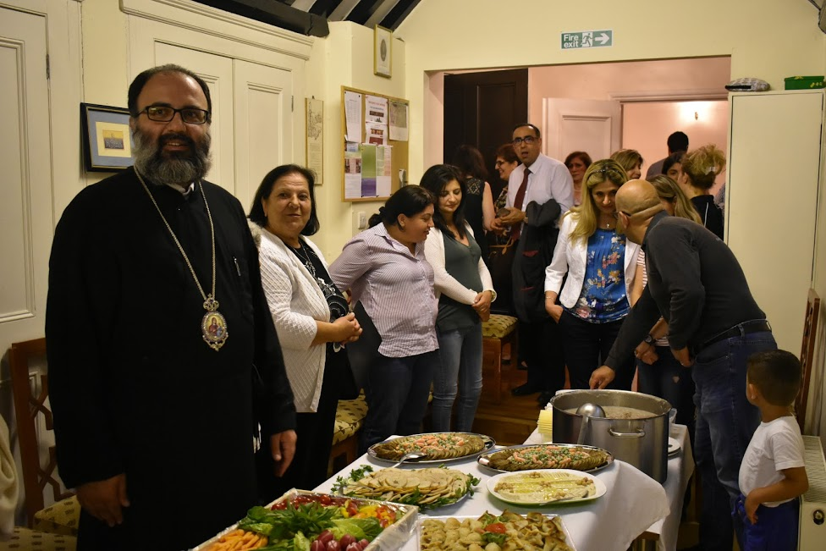

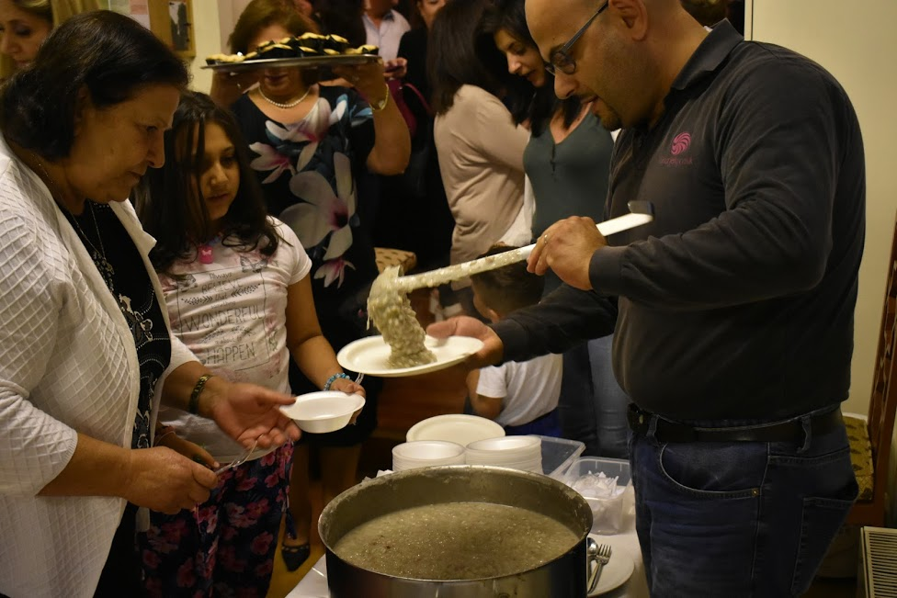

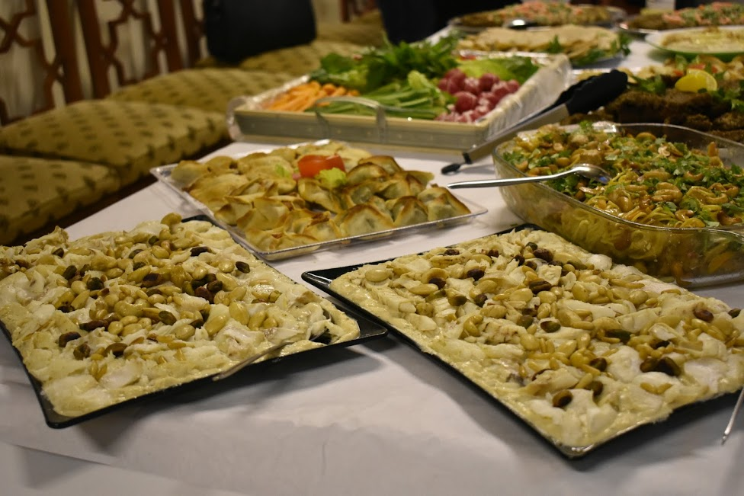

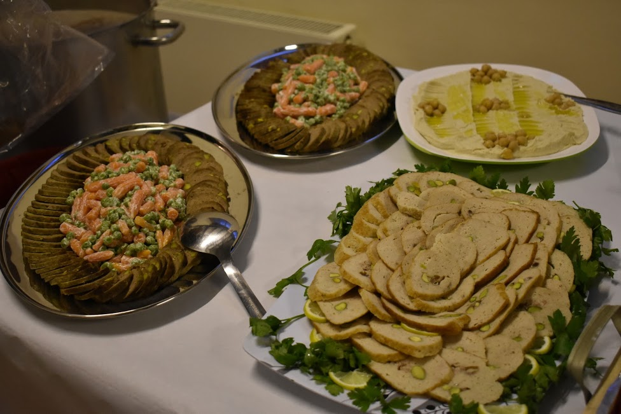

**تنشئة الأولاد**

**نبدأ تنشئة الأولاد من لحظة تكوينهم، فالجنين يسمع ويشعر وهو في أحشاء أمّه. تغضب الأمّ فيغضب الجنين، تشعر الأمّ بالحزن، بالألم، بالقلق... فيتأثّر الجنين بكلّ هذا. وعندما يكون في قلبها الفرح والسّلام تَنْقُلُ هذه الفضائل سِرًّا إلى مَنْ تَحْمِلُ في أحشائها. لهذا يجب على الأمّ أن تُصَلِّي كثيرًا خلال فترة الْحَمْلِ. سلوك الأولاد له علاقة مباشرة بحالة الأهل. عندما ينجرح الأولاد من سوء تصرّف الوالِدين، يفقدون قواهم وشوقهم للسَّير إلى الأمام ويُفْسِدُونَ بناء أنفسهم ويهدِّدُون هذا البناء للخطر. الإصلاح يَصير فقط بتقديس الأهل وتطهيرهم. صِيرُوا قدّيسين ولن تكون عندكم أيّة مشكلة مع أولادكم.**

**صَلُّوا أنتم الأهل، صَلُّوا بصمت وأياديكم مرفوعة نحو المسيح، معانقين أولادكم سِرًّا. وعندما يُحْدِثُون فوضى خُذُوا بعض التّدابير التّربويّة، لكن دون أن تَضْغَطُوا عليهم وبالأَخَصّ صَلُّوا. لا تكتفي الأمُّ بالملاطَفَة الحِسِّيَّة لولدها بل عليها أن تقدّم في الوقت نفسه دفء الصّلاة. يشعر الولد في عمق نفسه بالدّفء الرّوحيّ الّذي تَبْعَثُه أُمّه سِرِّيًّا له، فينجذب نحوها. يشعر بأمان واستقرار عندما تغمره الأمّ سِرًّا بالصّلاة الدّائمة وتحرِّرُه ممّا يُضَيِّقُ عليه. النّصائح والإرشادات الكثيرة تُسِيء كثيرًا ( القدِّيس بورفيريوس).**

**اذا تربّى الأولاد على عاداتٍ صالحة، فمن الصعب أن يبدّلوا تصرّفهم عندما يكبرون لأنّ نفس الطفل هي كالقماش الأبيض النظيف الذي إذا صبغناه بلونٍ ما يصطبغ جيداً ومهما حاولنا أن ندهنه ثانيةً فكثيراً ما يعود اللون الأول ليظهر ثانيةً. إذاً هكذا هم الأولاد الصغار عندما يعتادون على الصلاح يتبدّلون بسرعة. أغنوا أولادكم بالفضيلة بأسلوب العطف والحزم في آنٍ، وليس بخيراتٍ مؤقتة. لا تتركوا لهم الثروة بل التربية والفضيلة وهكذا لن يتكلوا على إرث الخيرات المادية وسينصرفون إلى تهذيب الذهن وبناء النفس ) القديس يوحنا الذهبي الفم(.**

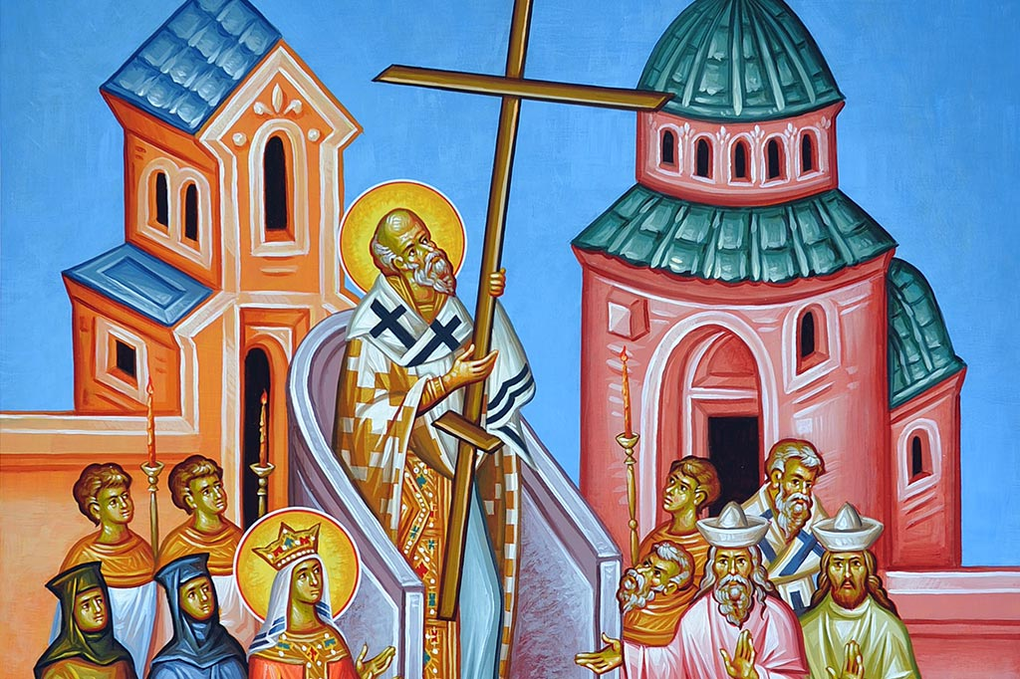

**The Elevation of the Holy Cross:**

The Feast of the Elevation of the Precious and Life-Giving Cross is celebrated each year on September 14. It commemorates the finding of the True Cross of our Lord and Saviour Jesus Christ by Saint Helen, the mother of the Emperor Constantine. Not only in memory of the event of the finding of the Cross, but also to celebrate how an instrument of shame was used to overcome death and bring salvation and eternal life.

The icon of the Feast tells the story of the finding of the Cross and of its Exaltation. Patriarch Macarius is standing in the pulpit elevating the Cross for all to see and venerate. On each side of the Patriarch are deacons holding candles. The elevated Cross is surrounded and venerated by many clergy and lay people, including Saint Helen, the mother of Emperor Constantine.

In the background of the icon is a domed structure that represents the Church of the Resurrection in Jerusalem. This church was one of the churches constructed and dedicated by Emperor Constantine on the holy sites of Jerusalem.

The Feast is an opportunity outside of the observances of Holy Week to celebrate the full significance of the victory of the Cross over the powers of the world, and the triumph of the wisdom of God through the Cross over the wisdom of this world. This Feast also gives the Church an opportunity to relish the full glory of the Cross as a source of light, hope and victory for Christ's people. It is also a time to celebrate the universality of the work of redemption accomplished through the Cross: the entire universe is seen through the light of the Cross, the new Tree of Life which provides nourishment for those who have been redeemed in Christ.

**Story and Lessons:**

**The important things**

One day, a wise teacher placed an empty jar on his desk. He proceeded to fill up the jar with ping pong balls until he could fit no more. He asked the students if they all agreed that the jar was full. Every student agreed. He then poured jelly beans into the jar. The jelly beans filled the spaces in between the balls. He asked the students again if the jar was full. Every student agreed. The teacher then poured sand into the jar. The sand filled in all of the empty space. He asked the class again if the jar was full.

Then the teacher said, “Students, I want you to realize this jar represents your life”. The balls represent the important things, like health, family, friends, and your salvations, they fulfil your life most. The jelly beans represent the other things in life like your career, home and responsibilities. The sand is everything small, if you put the sand in first, there is no room for anything else.

The same goes for life, if you spend all of your time and energy on the small stuff, you will never have room for the important things. So use your time wisely and focus on the things that make your life worthy! The rest is just sand.

**Fathers quotes:**

“The Most High planted in the middle of Paradise The thrice blessed wood, the gift of life for us, in order that, in approaching it, Adam might find eternal and immortal life, But he did not strive earnestly to know this life, And he failed to attain it, and revealed death. However , the robber, seeing how the plant in Eden Had been beautifully transplanted in Golgotha, Recognised the life in it and said to himself: This is what my father lost formerly in Paradise”.

**St Romanos the Melodist**

“The Cross, is wood which lifts us up and makes us great…. The Cross uprooted us from the depths of evil and elevated us to the summit of virtue”. **St John Chrysostom**

“Glory, O Lord, to the power of Thy Cross, which never fails! When the enemy oppresses me with a sinful thought or feeling, and I, lacking freedom in my heart, make the sign of the Cross several times with faith, suddenly my sin falls away from me, the compulsion vanishes, and I find myself free …. For the faithful the Cross is a mighty power which delivers from all evils, from the malice of the invisible foe”. **St John of Kronstadt**

**Announcements:**

**ببركة صاحب السيادة الميتروبوليت سلوان أونر ومجلس رعية كنيسة القديس جارجيوس سيتمّ افتتاح مدرسة تعليم اللغة العربية لأولادنا الأحباء من عمر أربع سنوات حتى عمر اثنتي عشرة سنة "مع بعض الاستثناءات" وذلك في أيلول القادم إن شاء الله، فعلى الراغبين تسجيل أسماء أولادهم لدى السيدة ماغي مخول مديرة المدرسة (07949187944 )، ليُبنى على الشيء مقتضاه.**

Our chairman Mr **Samir Hraiki** came back from his holiday, he is now back to his office, for any meeting don’t hesitate to contact him.

A Holy liturgy, will be celebrated for **the Elevation of the Holy Cross** on Thursday, September 13, 7:00 pm.

His Eminence Metropolite Silouan Oner will **Ordain Deacon Michael Touma** to the Priesthood, on Sunday September 30th, at the Cathedral of St George London, you are welcome.

**Sunday October 7th 2018**, the Antiochian Orthodox Society will hold its Annual General Meeting at 1.30pm in St. George’s Cathedral. All welcome

Saturday November17th,the Antiochian Orthodox Society will hold its **Annual Charity Dinner** at 7.30pm in the Royal Garden Hotel. Tickets will be available in October.

**A Fair of handmade products** is projected; who is interested to help, please get in touch with Deacon Michael Touma, the event will take place on Sunday 2nd of December after the Holy Liturgy.